**Assignment-2**

**Q 1 Write a program to find sum of all integers greater than 100 and less than 200 that are divisible by 7.**

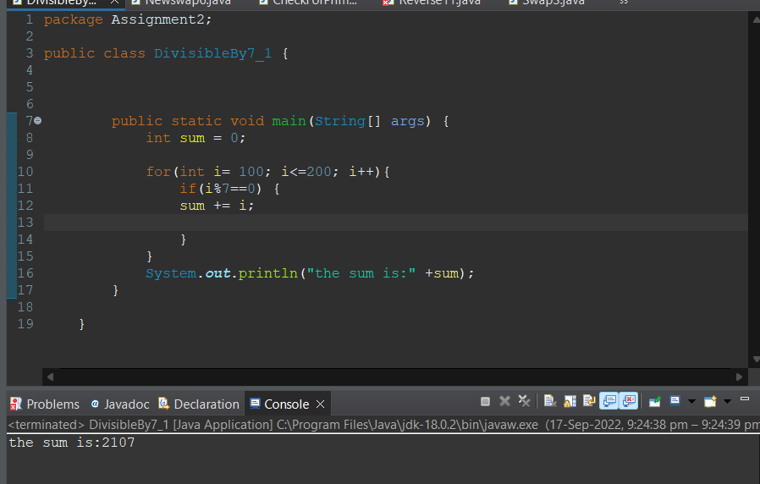**2 Write a program in java that ask three numbers from  
user and print the greatest among three .**

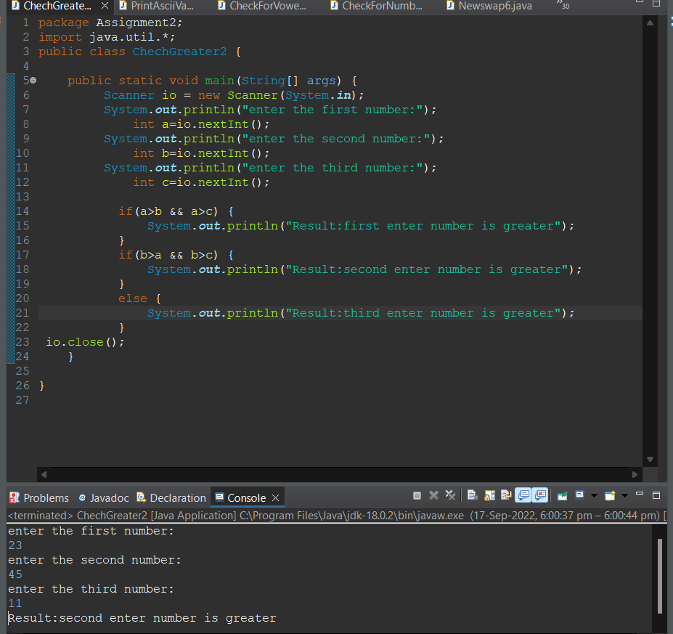

**3. WAP to find  ASCII value of a character .**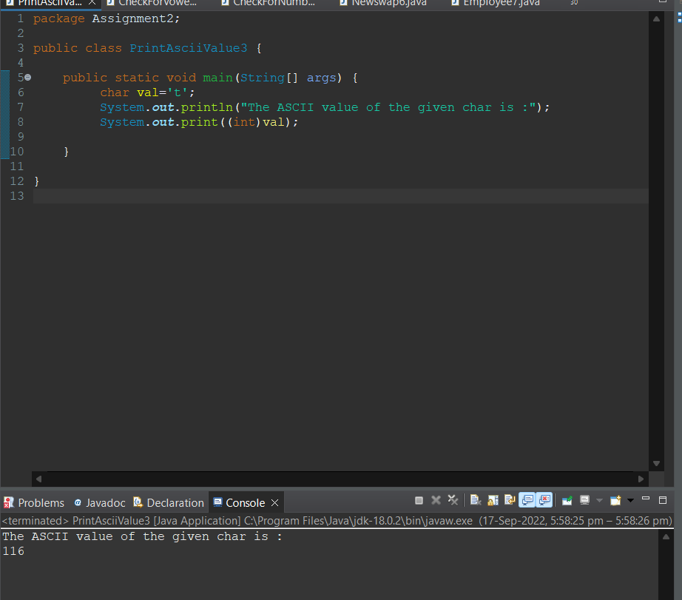

**4. Java Program to Check Whether an Alphabet is Vowel or Consonant**

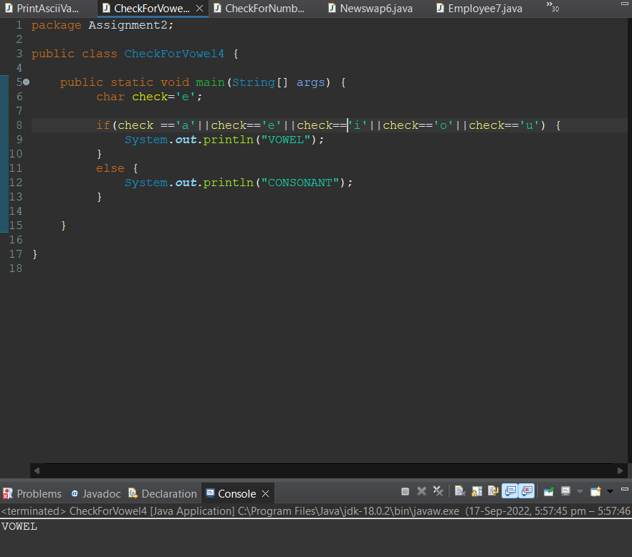

**5 Check if a Number is Positive or Negative using if else**

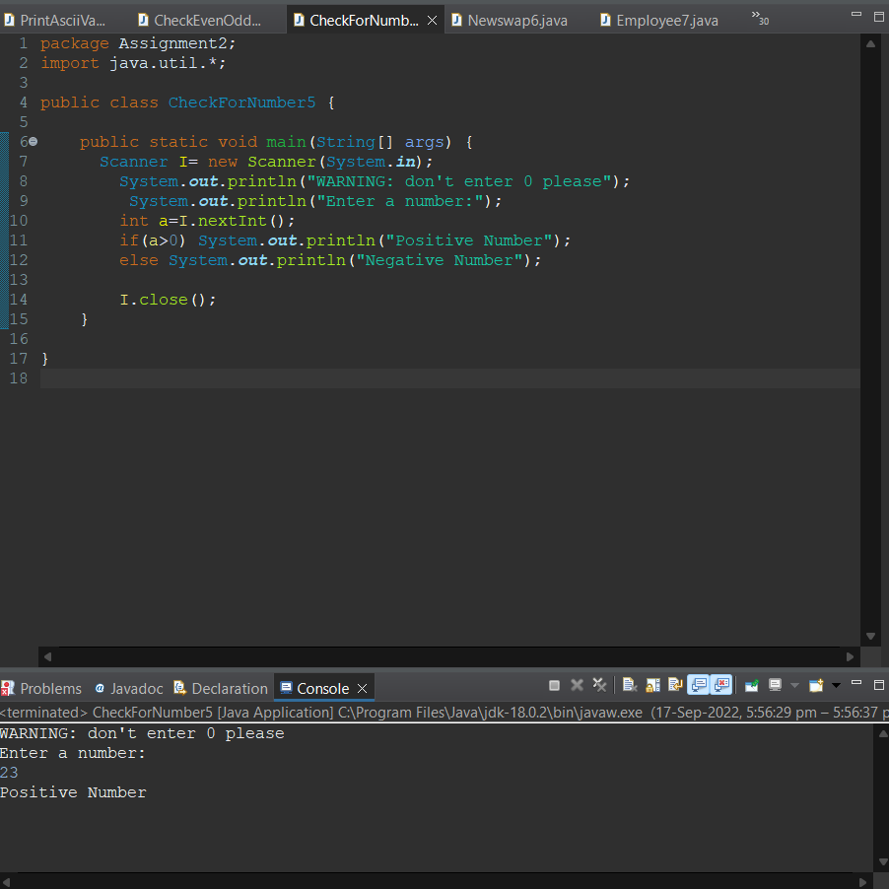

**6 WAP for swapping two numbers without using third variable**

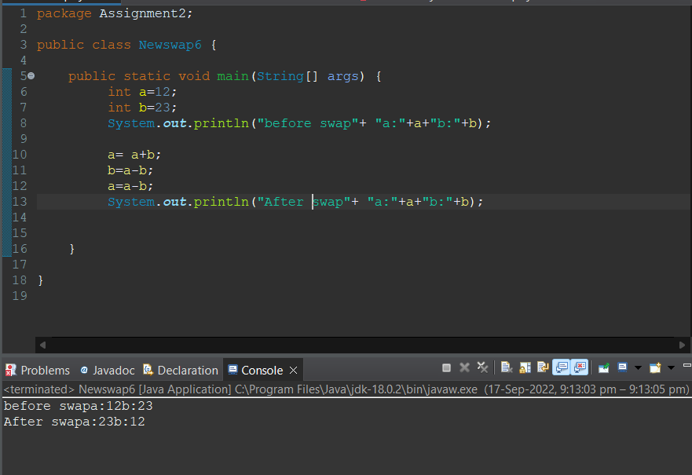

**7 Write a program that would print the information (name,  
year of joining, salary, address) of three employees by creating a class named  
'Employee'. The output should be as follows:  
  
Name           Year of joining        Address  
  
  
Ashish            
1994                       64C- WallsStreat  
  
  
Sam                 
2000                     68D- WallsStreat  
  
  
John                 
1999                    26B- WallsStreat**

**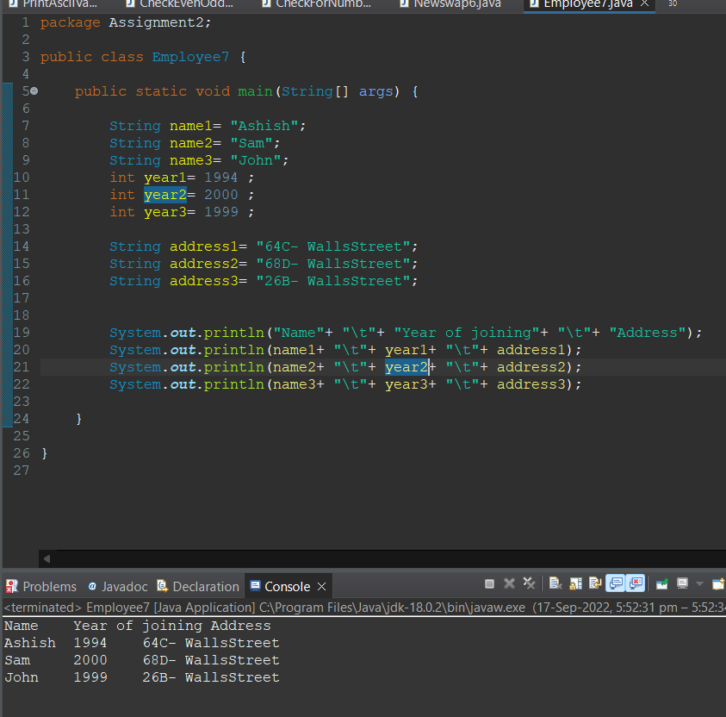  
  
  
8 WAP to input basic salary of an employee and calculate its  
Gross salary according to following:**

**Basic Salary <= 10000 : HRA = 20%, DA = 80%  
  
  
Basic Salary <= 20000 : HRA = 25%, DA = 90%  
  
  
Basic Salary > 20000 : HRA = 30%, DA = 95%**

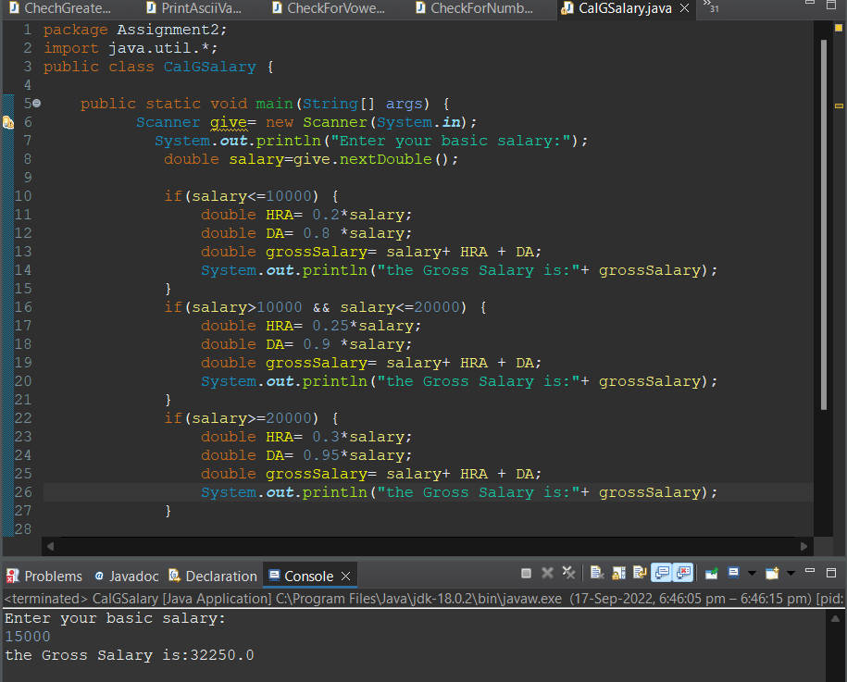

**9 Q  wap to print even numbers between 10 to 20.**

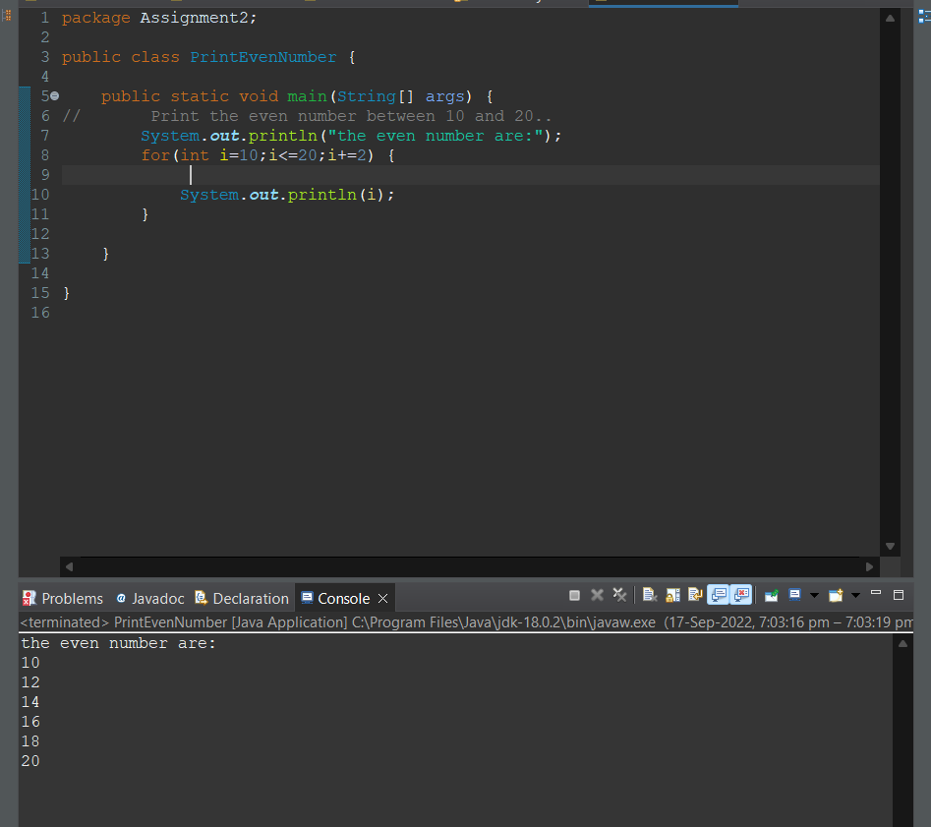

**10 wap to check if a number is prime or not.**

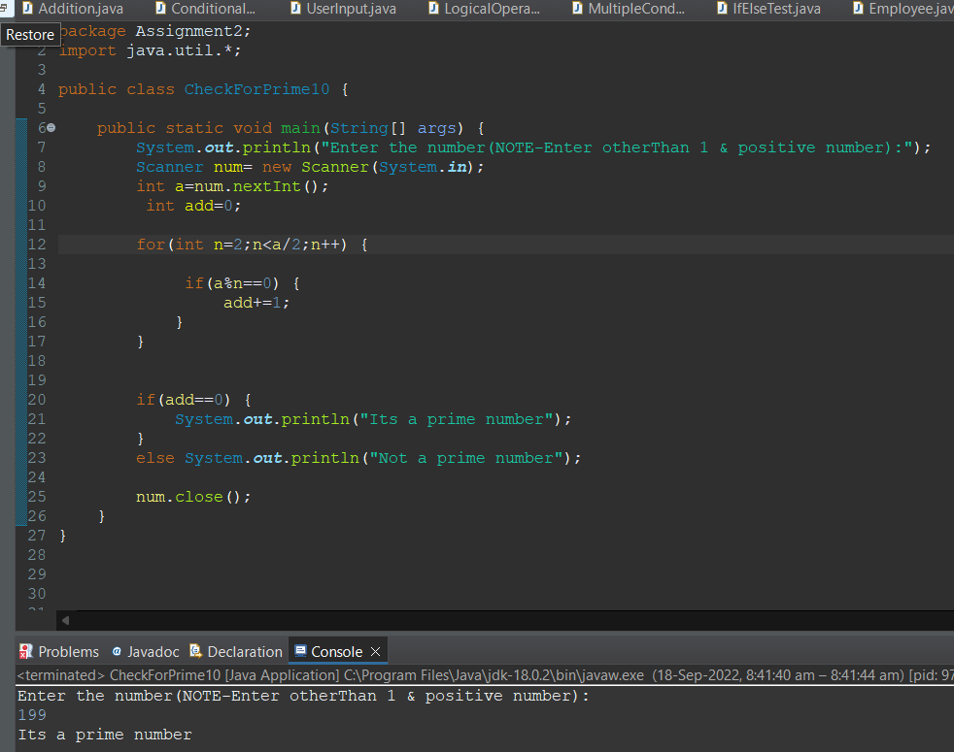

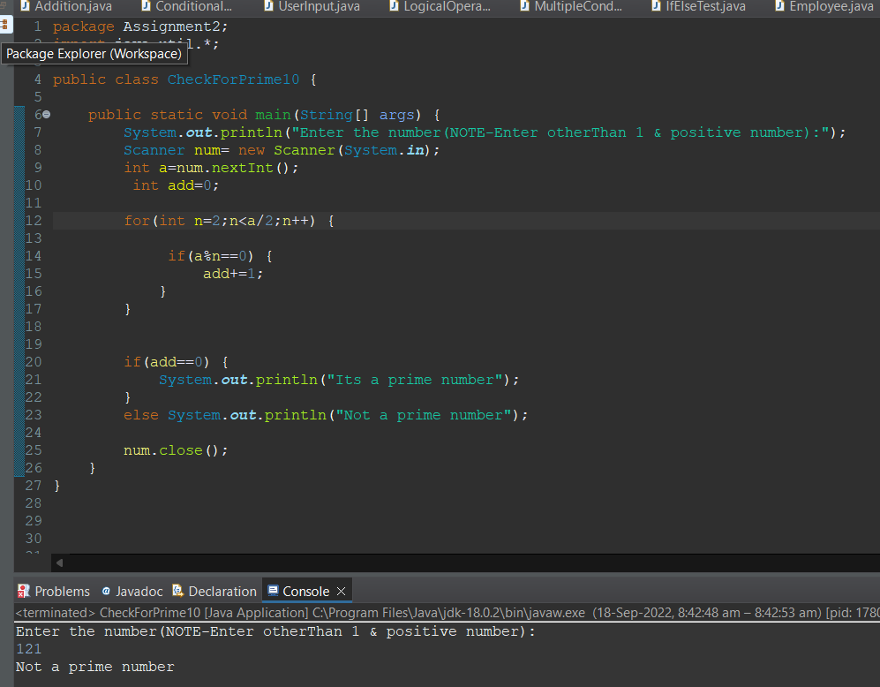

**11 wap to reverse a given digit   123   321.**

